1. **Installing a web server**

Convenient to use is a wampserver, so install it. You can download it at <https://www.wampserver.com/en/>

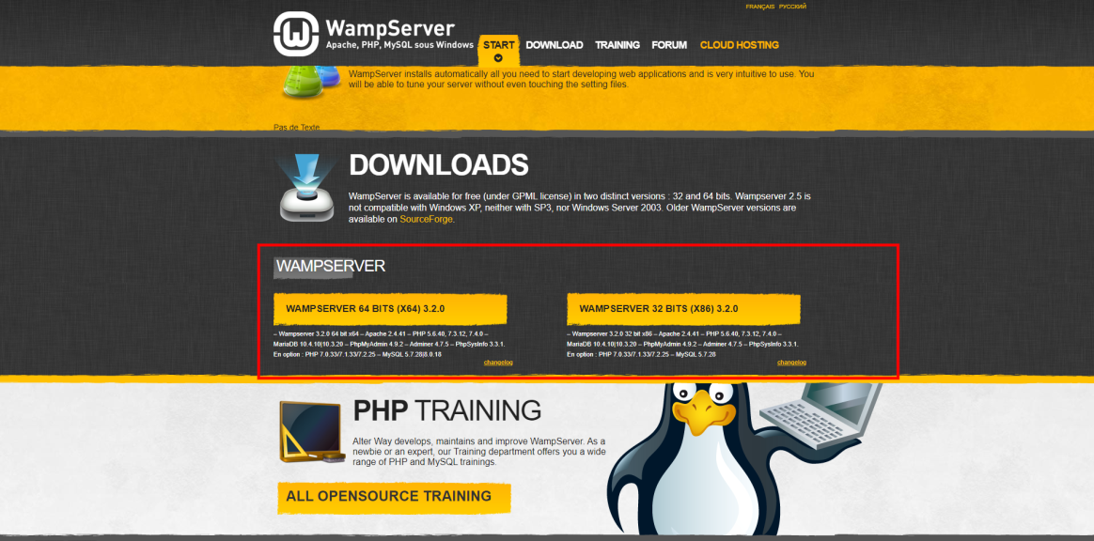

Select the version according to the operating system and download.

1. **Installing the composer globally.**

### Using the Installer

This is the easiest way to get Composer set up on your machine.

Download and run  [Composer-Setup.exe](https://getcomposer.org/download/). It will install the latest Composer version and set up your PATH so that you can call composer from any directory in your command line.

**Note: Close your current terminal. Test usage with a new terminal: This is important since the PATH only gets loaded when the terminal starts.**

1. **Creating a database**

After installing and running the wampserver, a server icon will appear on the taskbar (bottom right). Clicking on it with the left mouse button will open a menu in which you need to select phpmyadmin.

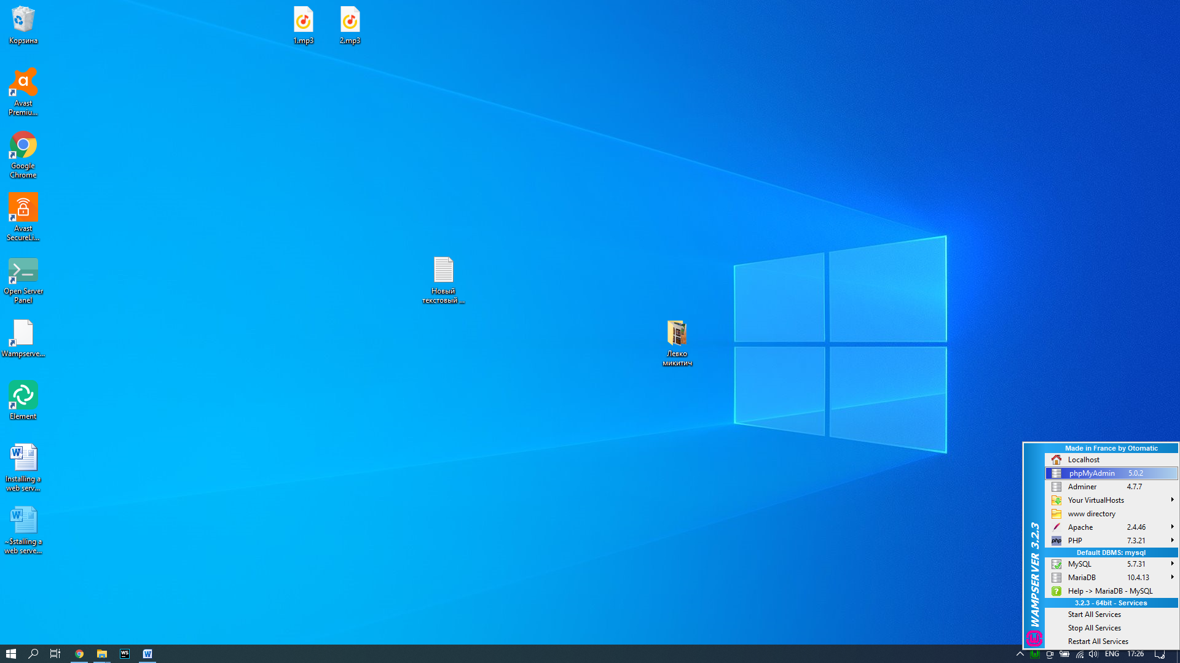

After selecting phpmyadmin in the browser, the login page will open. Login and password default root root. after entering the login and password, the database management page will open.

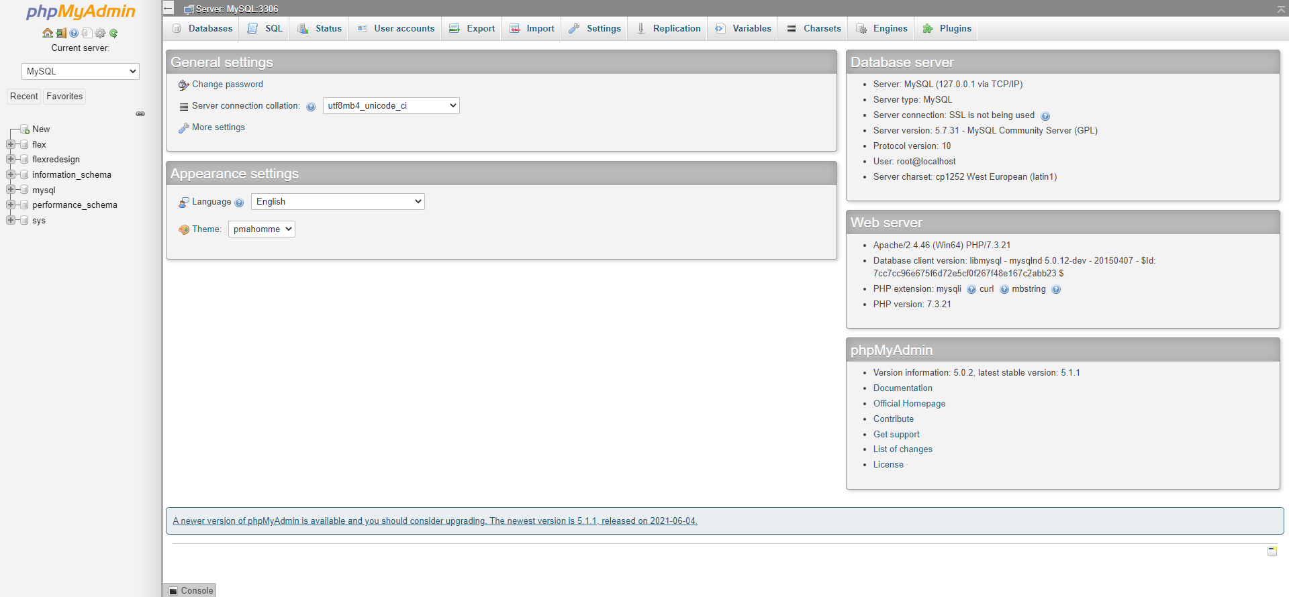

On this page, click "New"

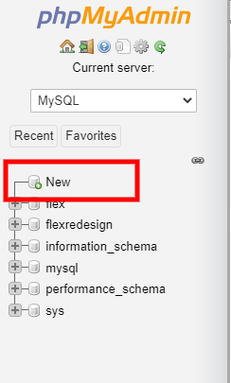

After clicking the “New” button, the database creation page will open.

Enter the name of the database and select the encoding type (utf8_general_ci) and click create.

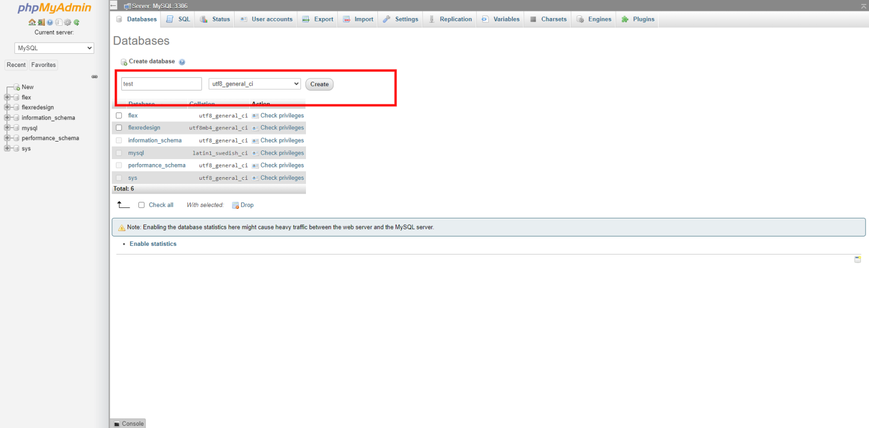

1. Project installation

Go to the folder where our project will be located. To do this, on the taskbar, left-click on the wampserver icon and select “www directory”

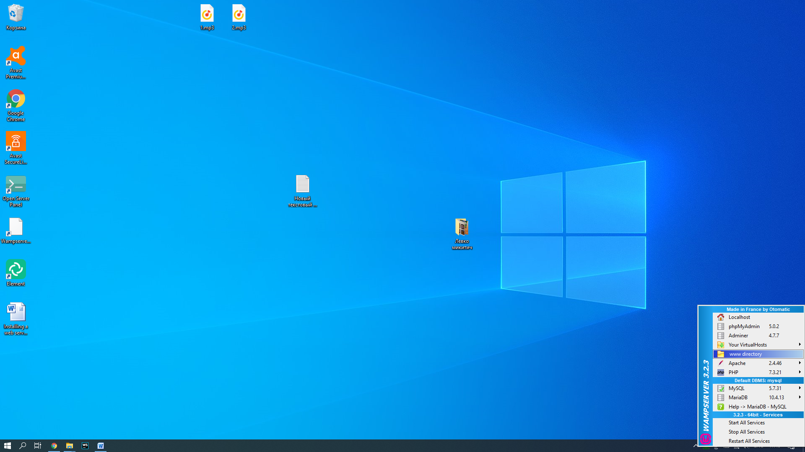

After clicking, the folder where the project should be located will open. You need to start the terminal in this folder. To start the terminal in this folder you need to select "File" in the folder menu at the top left and select "windows powershell" in the menu that opens.

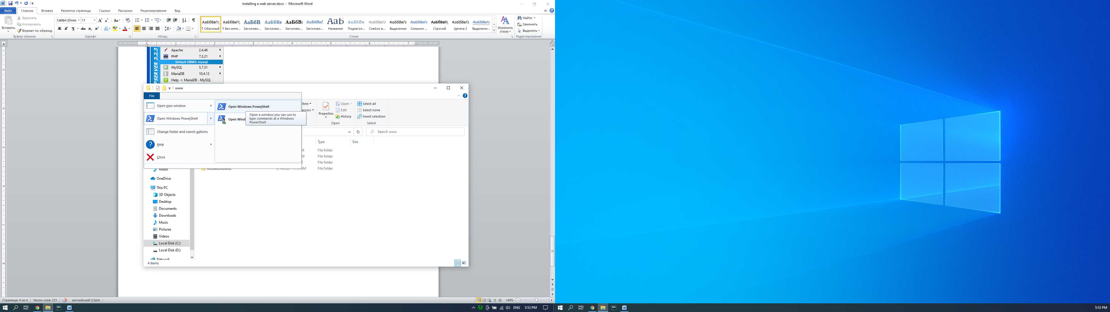

The terminal requires command “ git clone <https://git.redoo-networks.com/Redoo-Networks/flexx.suite/Core.git> “

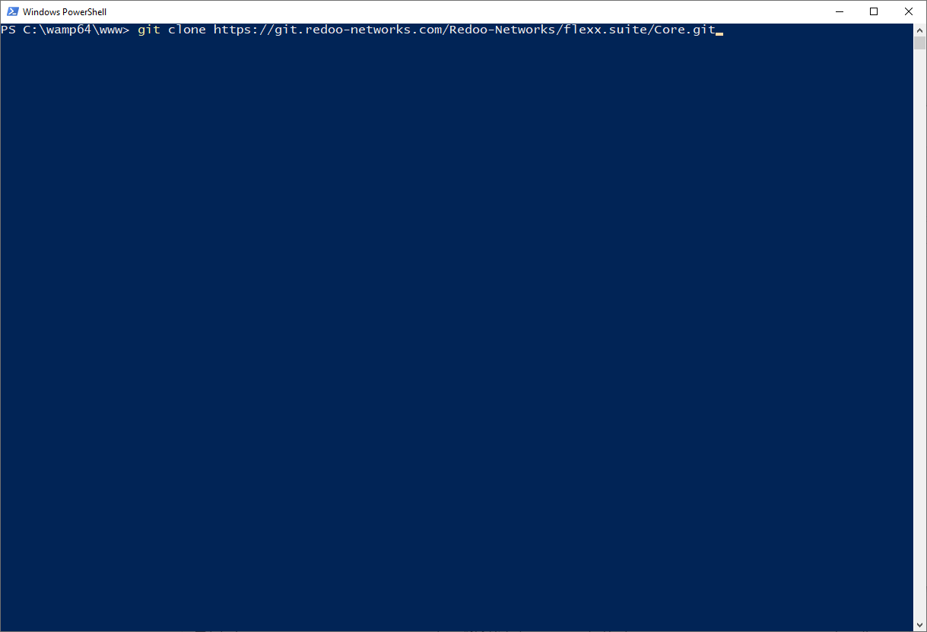

After copying in the folder with the project finds a file README in which the following steps for installation are specified.